**Lesson Plan #4**

**CSEE5590-0005/490-0005- Fall 2018**

**IOT / Robot Programming**

**[ICP Feedback and Submission Link](https://goo.gl/forms/WKoUtuZTIesiugDl2)**

**Lesson Title:** Building Sample Flow on NodeRed and accessing webservice

**Lesson Description:** *Post weather details from openweathermap on social network (twitter)*

**In Class Exercise :**

**ICP :**

1. **Create your own credentials for openweather map and twitter web service**
2. **Wire the necessary nodes for building the flow and post the weather details on twitter**

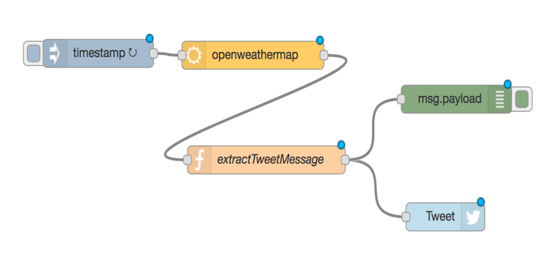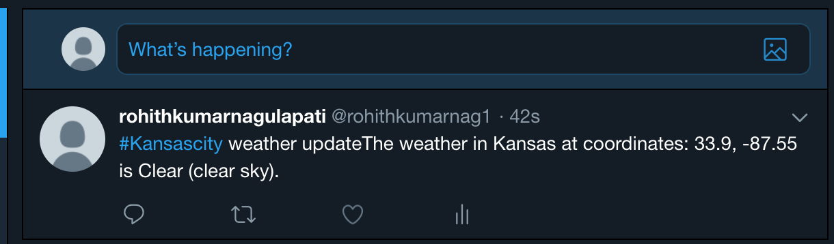

**ICP Guidelines (In Class Students):**

1. ICP Submission is in pairs of two students.
2. Once completed, must be presented to TA or Instructor before the completion of the class
3. Submission after class is considered as late submission. (Check the late submission policy in the syllabus)
4. Record a video of your working project with brief explanation
5. ICP Code with brief explanation and recorded video should be pushed to GitHub for evaluation of the grade.